- [5 marks]
Convert the following units
a) 3cm = ___________ mm  b) 8m = ___________ cm  c) 3000m = ___________km | d) 8cm² = ___________ mm²  e) 21500 m² = ___________ km²

- [10 marks]
- Find the perimeter of the following
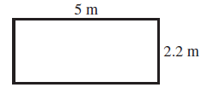 | 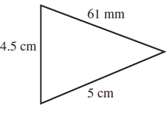
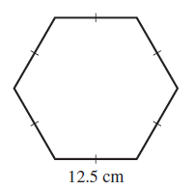 | 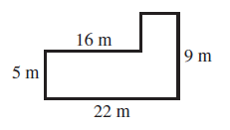
- A square has a perimeter of 12m, what is the length of its sides?

- [8 marks]
Find the Area of the following
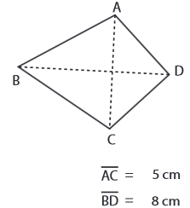 | 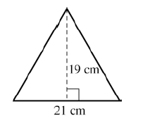
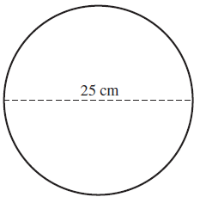 | 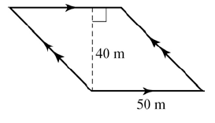

- [3 marks]
Sally needs to fence her country house block to keep her dog in. The block is a rectangle with length 50m and width 42m.
- How much fencing will she need to fence her block?

- If it costs $13 per meter, how much will it cost to fence her block?

- [3 marks]
A landscape gardener charges $20 per square meter of lawn. A lawn area in the shape of a rhombus and its diagonals are 8m and 14.5m. What would be the cost of laying this lawn?

- [6 marks]
Use the following tables to determine the rule and plot on the Cartesian plane.
x -2 -1 0 1 2  y -3 0 3 6 9  Rule:_____________________ | 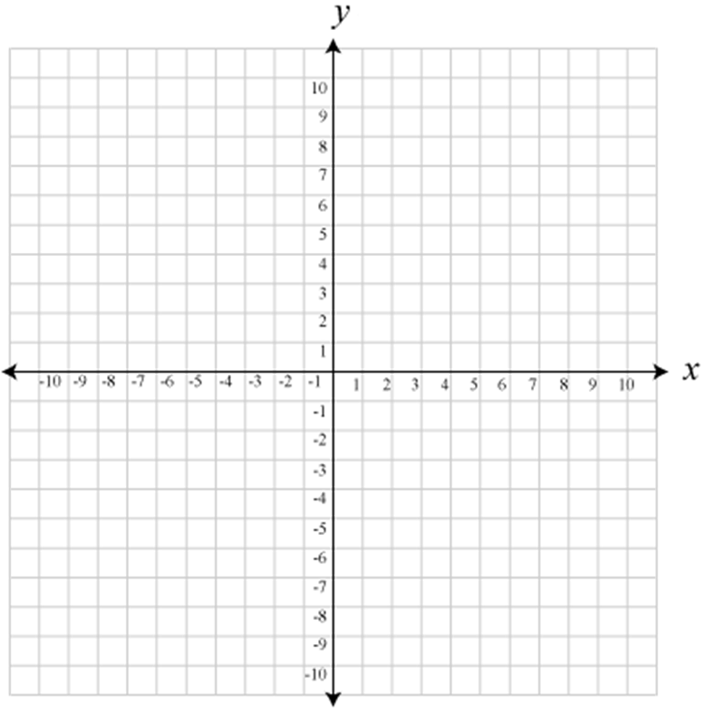
x | -2 | -1 | 0 | 1 | 2
y | -5 | -3 | -1 | 1 | 3

Rule:________________________

END OF TEST

